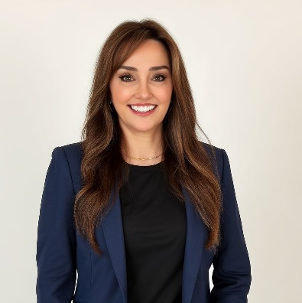





Education
Bachelor’s degree
Florida State University
B.S., Finance

Achievements
Award/Achievements
SkinCeuticals
- 2020, 2018 & 2017
President’s Club Winner
- Regional Account Executive of the Year
- 106% goal attainment
- Impact Award
- Hustle Award
- Regional Field Trainer
- Marketing Advisory Board
- Dermablend Advisory Board
- 2017 Rookie of the Year
- Regional Highest Percent to Goal Award
- Surpassed new account expectations by 50%

Award/Achievements
Organization
20XX

Professional summary
Award-winning Business Development Manager with extensive expertise in medical sales and strategic planning. Proficient in account management, strong business relationships, revenue growth and leading diverse teams in a highly competitive market.

Work Experience

Business Development Manager – Flagship Accounts

SkinCeuticals, Southeast | 2021 – present
Lead strategic planning and revenue growth initiatives for SkinCeuticals exclusive flagship accounts, achieving notable sales growth. Secure new flagship partnerships, lead contract negotiations and successful new flagship launch events.
- Conduct quarterly business reviews, working with our business partners to identify growth opportunities and formulate sales strategies and goals, driving measurable growth.
- Identified top SkinCeuticals accounts to convert to exclusive flagship partners, leading contract negotiations and developing trusted relationships to increase revenue to a commitment of $100,000 - $300,000 per flagship each year.
- Lead seamless coordination with nine account executive and four regional sales managers to support and grow flagship partners.
- Coordinate retail flagship buildouts and installations ensuring timely and effective project plans.

Senior Account Executive

SkinCeuticals, Tampa | 2016 – 2021
3-time President’s Club winner for driving sales growth in medical skin care with plastic surgery, dermatology and Med-Spa practices.
- Opened numerous new accounts, expanding market presence in highly competitive market.
- Spearheaded strategic partnerships, implementing comprehensive product education programs and driving measurable growth.

.
813-810-4476
TiffanyLarson28@gmail.com
Tampa, FL
https://www.linkedin.com/in/tiffanyclarson/

Contact

tiffany larson

Skills
- Business Development
- Account Management
- B2B
- Medical Sales
- Strategic Planning
- Team Leadership
- Client Relations
- Revenue Growth
- Market Analysis
- Contract negotiations
- Retail Marketing
- Teamwork

Achievements
Award/Achievements
Americair
- Medical representative of the Year Award
- Increased new accounts 238%
- Excellence in Achievement Award

Work Experience

Professional Medical Representative

Taro Pharmaceuticals, Tampa | 2004 – 2016
Promoted dermatology pharmaceuticals to specialists, boosting sales significantly. Built strong relationships with high volume physicians, achieving measurable results.
- Nationally ranked in the top 10 for individual products.

Professional Sales Associate

Aventis Pharmaceuticals, Tampa | 2001 – 2004
- Led sales of insulin and diabetes products to healthcare professionals in the Tampa area.
- Developed strong relationships with endocrinologists and primary care providers.

Medical Representative

Roche Pharmaceuticals, St. Petersburg | 1997 – 2001
- Effectively managed sales of antibiotic, gastrointestinal lipase inhibitor, neuraminidase inhibitor, NSAID, estrogen blocker and calcium channel blockers to a large client base of primary care physicians, endocrinologists, and OB/GYNs.

General Manager/Sales Manager
Medical Sales Representative

Americair Home Respiratory, Largo | 1993 - 1997
- Managed sales representatives, respiratory therapists and office staff for a national respiratory home care company.
- Responsible for sales of respiratory home care equipment in a large central Florida territory

Pharmaceutical Representative

Burroughs Wellcome Company, Tallahassee | 1994 – 1995
- Managed territory to increase market share of BW products to doctors, hospitals and pharmacists. Therapeutic areas include: antiherpetics, antidepressants and neuromuscular blockers

Tiffany larson

